The Power Diet: Slimming Down Energy Use in IEEE 802.15.4 and Zigbee Networks

Judy Chua
Bachelor of Science in Computer Science Major in Network and Information Security
De La Salle University
Arwyn Gabrielle Telosa
Bachelor of Science in Computer Science Major in Network and Information Security
De La Salle University

Manila, Philippines
judy_chua_b@dlsu.edu.ph

Manila, Philippines
arwyn_telosa@dlsu.edu.ph

Abstract— This study presents a comprehensive exploration of energy optimization strategies within IEEE 802.15.4 and ZigBee protocols for Wireless Sensor Networks (WSNs). Given the constraints of battery-powered nodes, energy efficiency is critical for extending network lifespan, particularly in remote or hard-to-reach areas. Building on existing research, this work examines adaptive duty cycling, optimized sleep modes, and dynamic transmission power adjustment as methods to mitigate energy consumption while maintaining network performance and reliability. By evaluating cluster-tree scheduling, adaptive transmission adjustments, and node deployment strategies, this research outlines a practical framework for balancing energy savings with operational demands. Findings show that collision-free scheduling, dynamic superframe adjustments, and strategic topology choices can substantially reduce power use, reinforcing WSNs' sustainability in IoT applications. The proposed optimizations aim to reduce maintenance frequency and operational costs, ultimately supporting the development of energy-efficient, long-lasting WSNs suitable for diverse real-world applications.
Keywords— ZigBee, IEEE 802.15.4, Wireless Sensor Networks, energy efficiency, IoT

Introduction
More energy-efficient wireless sensor networks using IEEE 802.15.4 and ZigBee protocols are essential in the growing number of Internet of Things (IoT) applications, as these protocols are typically utilized primarily for their low-cost and low-power benefits. From fundamental industrial monitoring to complex building automation, these end-to-end protocols play a vital role in helping the system overcome an array of reliability issues. On the contrary, the primary factor influencing a network's lifespan and operating expenses is energy consumption. The majority of Wireless Sensor Network (WSN) nodes are powered by power sources, which can be costly and hard to replace on a regular basis in isolated or remote areas. This paper discusses how the IEEE 802.15.4 and ZigBee protocols can be optimized to save energy and require less frequent maintenance while extending the lifespan of such networks.
The primary objective of this project is to explore and suggest protocol changes that eliminate energy waste without compromising network performance or dependability. In order to increase node performance for real-world applications, this research focuses on strategies such as adaptive duty cycling, optimal sleep modes, and dynamic changes in the transmission power. Previous work's simulation-based evaluation of energy consumption, cluster tree architecture, and energy-efficient scheduling would all be considered. In this paper, the various configurations that could affect energy usage will be examined. These results are useful for creating long-lasting, sustainable WSNs in the Internet of Things so that applications in the real world can function optimally with lower power needs.

Review of Related Literature

An Energy Efficient Schedule for IEEE 802.15.4/ZigBee Cluster Tree WSN with Multiple Collision Domains and Period Crossing Constraint.
In light of the constraints imposed by limited battery life and the pressing need for longer network operation, energy efficiency in Wireless Sensor Networks (WSNs) that use IEEE 802.15.4/ZigBee protocols has emerged as a research focus. Ahmad and Hanzalek's (2017) [1] study addresses the subject by looking into the importance of cluster scheduling in ZigBee cluster-tree networks, specifically how to reduce energy usage by using a collision-free scheduling method that adheres to data flow deadlines. The study shows how WSN nodes can remain in low-power states for longer periods of time by strategically allocating Guaranteed Time Slots (GTSs) and scheduling cluster activations optimally. This reduces energy usage and maximizes network longevity. This study emphasizes the importance of efficient scheduling in energy conservation and shows how these scheduling techniques can be tailored to satisfy real-time data restrictions in time-sensitive applications.
The present research extends Ahmad and Hanzalek's [1] approach to investigate practical, implementable solutions for power reduction in WSNs using IEEE 802.15.4/ZigBee protocols. Recognizing that severe duty cycling might cause delays that are difficult to handle in time-sensitive settings, this study seeks to achieve a compromise between energy conservation and data transmission timeliness. By investigating and implementing collision-free schedules and time-division algorithms in a controlled setting, this study hopes to provide an approach that improves energy efficiency without sacrificing responsiveness. Such a strategy improves the dependability and scalability of WSNs, particularly in applications that require both longer network lifespans and rigorous data delivery deadlines.

Energy efficiency in WSN: IEEE 802.15.4
In "Energy Efficiency in WSN: IEEE 802.15.4," Ayadi et al. [3] tackle the issue of energy saving in Wireless Sensor Networks (WSNs), focusing on the IEEE 802.15.4 protocol in beacon-enabled mode. This protocol is intended to enable low-power, low-data-rate applications often seen in WSNs, where energy efficiency is essential for the long-term operation of battery-powered nodes. The authors suggest a method for modifying the Superframe Duration (SD), which determines active and passive communication intervals based on the remaining battery energy. The study's goal is to lower energy usage without altering the IEEE 802.15.4 standard, hence prolonging node lifetimes while preserving network performance.
Using the INETMANET/OMNET++ simulator, the authors show that dynamically adjusting SD based on energy levels can significantly reduce energy use during data transmission and reception while boosting energy savings during sleep periods. This adaptation reduces the duty cycle from 25% to 6.25%, conserving power and increasing node longevity. This study is crucial for studies on WSN energy efficiency since it provides a simple, effective method for energy management in IEEE 802.15.4-based networks. Its findings on beacon-enabled modifications are especially relevant to research on adaptive duty cycling and power management tactics, laying the groundwork for adopting sustainable energy solutions in resource-constrained WSN applications.

Modeling and Analysis of Energy Consumption for ZigBee-based Wireless Sensor Networks
To define and understand Zigbee’s operation within wireless sensor networks, Ouyang et al. (2012) [5] analyzed and attempted to predict how Zigbee devices consume energy, focusing on energy efficiency. This is especially important, as power consumption is a key challenge for Zigbee devices due to their need for continuous operation despite their brief lifespan. In their analysis, the authors first measured the devices' energy consumption by calculating the average consumption during startup, network initialization, idle time, and other operations performed by each device. These measurements were taken across the three types of Zigbee devices being tested. Using these findings, they began to construct a model that could predict the energy consumption of each device, observing that energy is consumed with each operation regardless of the Zigbee device type. This model was then verified by simulating the devices in a networking simulator.
Constructing different network topology structure in their network simulator, their findings include the following: The communication distance between each devices greatly affects the energy consumption. When devices are either too close or too far apart, energy usage increases, likely due to signal adjustment overhead or higher power requirements to maintain connection. However, at a medium distance, energy consumption is minimized as this distance optimally balances signal strength and transmission power. Additionally, increasing the communication range decreases energy consumption per transmission, as there is less overhead. The larger the range, the more efficient the network becomes in terms of total energy use. In the end, these findings were aligned with the mathematical model proposed by the authors and offer valuable insights for future research focused on designing energy-efficient wireless sensor networks.

An IEEE 802.15.4/ZigBee based wireless sensor network for Energy Efficient Buildings
Gezer, Niccolini, and Buratti's (2010) [2] study on the deployment of IEEE 802.15.4/ZigBee in energy-efficient building systems provides insights on how Wireless Sensor Networks (WSNs) could aid with sustainable energy management in residential and commercial instances. This study, conducted as part of the European Commission-funded eDIANA project, investigates the feasibility of employing ZigBee-compliant devices to monitor and manage energy use by various appliances, indicating that real-time data on energy use can enable efficient control strategies. The study uses both simulations and real-world testing to assess measures such as packet error rate, latency, and energy usage. The results show that ZigBee mesh networks are efficient in meeting the eDIANA project's aims for reduced energy usage, highlighting the potential of wireless networks in optimizing energy use in smart buildings.
This paper is pertinent to current research efforts aimed at improving energy efficiency in WSNs that use IEEE 802.15.4/ZigBee protocols. Gezer et al.'s work contributes to the study's overarching goal of reducing power consumption while preserving network reliability by offering insights into practical deployment factors such as node placement, packet error rates, and network topology effects. Their investigation of ZigBee mesh networks in controlled situations is consistent with our goal of designing low-power solutions that increase network lifetime while maintaining performance. The findings of this study will help to provide the groundwork for developing energy-efficient procedures and control strategies, particularly for WSNs deployed in time-sensitive, power-constrained situations.

Reliability and Energy-Efficiency in IEEE 802.15.4/ZigBee Sensor Networks: An Adaptive and Cross-Layer Approach
In the paper titled "Reliability and Energy-Efficiency in IEEE 802.15.4/ZigBee Sensor Networks: An Adaptive and Cross-Layer Approach," Di Francesco et al. [4] address the dual challenges of reliability and energy efficiency in Wireless Sensor Networks (WSNs) that use the IEEE 802.15.4 and ZigBee standards. Given that WSNs are installed in remote areas where nodes must run independently with limited battery power, the study underlines the importance of energy-saving measures that do not compromise network dependability. To do this, the authors offer an adaptable, cross-layer framework that incorporates the ADAPT (ADaptive Access Parameters Tuning) algorithm, which customizes MAC layer settings based on network topology and traffic conditions. This method enables WSNs to adjust autonomously, reducing energy consumption and increasing network lifespan while meeting application-specific dependability requirements.
The study's findings, which were validated by simulations, show that ADAPT maintains near-optimal energy efficiency and low latency under a variety of network situations, including dense node configurations and multi-hop scenarios. This cross-layer adaptability is crucial for dealing with the dynamic nature of WSNs, as fixed configurations might waste energy and result in faulty data transmission. This work presents a validated approach for addressing the energy-reliability trade-off in research focusing on improving the IEEE 802.15.4 and Zigbee protocols. Integrating ADAPT-like adaptive strategies is critical to the current study's goals of extending WSN operational life through adaptive duty cycling, optimized sleep modes, and regulated transmission power—promising improvements that could make WSNs more sustainable and effective in real-world applications.

Methodology
This study conducted a comparative literature review about ZigBee and IEEE 802.15.4-based Wireless Sensor Networks (WSNs) protocols to discover a way to improve energy consumption power due to its limited lifeline and continuous operation. Numerous research papers were analyzed and compiled to combine their findings, which will be then compared to ChatGPT’s initial findings whether they would be aligned or not. This is to verify whether ChatGPT is reliable in providing future assistance in further enhancing the potential of the research.

Discussion and Findings
In systematically reviewing the findings and solutions proposed in the studies about the topic, it was discovered that there are multiple ways to efficiently decrease the energy consumption of wireless sensor network devices using the ZigBee and IEEE 802.15.4 protocols. First, it was proposed by Ahmad and Hanzalek [1] that having a collision-free scheduling method would optimize energy use in ZigBee networks by reducing the need for nodes to resend messages after collisions. This solution improves energy efficiency and supports responsiveness, a crucial feature in ZigBee cluster-tree WSNs. In relation to that, Ayadi et al. [3] proposed a dynamic superframe duration to extend device battery life by adjusting active time based on battery levels and activity to maximize its potential while conserving energy at a later time. Additionally, this method conserves energy without altering the protocol, allowing for longer battery life in devices.
Implementing both solutions can optimize energy efficiency by minimizing message retransmissions and extending battery life through adaptive active periods. However, network topology design is also crucial, as it significantly impacts energy consumption. Ouyang et al. [5] developed a model to analyze and reduce energy usage in WSNs, showing that energy consumption varies based on device operation modes and communication distances.
Gezer, Niccolini, and Buratti [2] tested an energy-saving approach by deploying ZigBee protocols in a building using a mesh network. By enabling continuous communication between various building appliances, they achieved effective energy reduction, promoting sustainable energy use. However, it is important to note that reliability also poses a problem in wireless communication especially in ZigBee. Di Francesco et al. [4] propose an algorithm that caters to both problems in their study. This algorithm allows real-time node updates and dynamically adjusts network topology to manage traffic between nodes, thus improving energy management. This provides a solution in handling the nature of real-world applications of WSNs considering how it adjusts the settings based on what is needed.

ChatGPT Findings
To start, the researchers first started to ask ChatGPT for its opinion by sending a prompt that asked for their suggestions for improving ZigBee and IEEE 802.15.4-based wireless sensor networks regarding their energy consumption. ChatGPT provided solutions and strategies closely aligned with those considered in the study, specifically focusing on the following main areas: Adaptive Duty Cycling, Sleep Mode Optimization, Adaptive Transmission Power Control, Data Aggregation and Compression, Efficient Routing Protocols, Traffic-Aware Scheduling and Clustering, Cross-Layer Optimization, and Energy Harvesting and Management. This demonstrates ChatGPT’s usefulness as a starting point for research due to its relevant and aligned responses.

Cluster Tree
ChatGPT was requested to showcase an energy efficiency method in a ZigBee network in order to confirm that it was consistent with the study [1]. In response, ChatGPT presented a solution that closely matches the study's methodology and focuses on collision avoidance and energy optimization. In line with the study's emphasis on spatial reuse and time-constrained data flows, it suggested hierarchical TDMA scheduling, adaptive beacon synchronization, and duty cycling. The other suggestions by ChatGPT such as data aggregation and route optimization and adaptive transmission power control, were not considered in the study [1]. This may be due to ChatGPT having more information access now compared to the study in 2017. In a cluster-tree topology, both strategies prioritize minimizing retransmissions and optimizing energy efficiency, guaranteeing conformity with the study's conclusions for collision domains and periodic schedules. This shows that ChatGPT is able to provide results aligned with the study.

Energy Efficiency
Prompted to provide a strategy for energy efficiency in a WSN using IEEE 802.15.4, ChatGPT's response aligns closely with the findings of the study. It proposed starting with monitoring network traffic and adjusting duty cycles, which echoes the study’s focus on dynamically adjusting duty cycles based on network activity. Additionally, ChatGPT suggested implementing adaptive duty cycling, similar to the study’s approach, where nodes adjust their sleep and wake times in response to changes in network load. The subsequent steps of evaluating performance metrics like latency and energy consumption also mirror those outlined in the study. Overall, ChatGPT's strategy reflects the key ideas and methodologies found in the research.

Modeling and Analysis of the Protocol
The AI was also tasked with creating a model and generating graphs showing the relationship between energy consumption, distance, and communication range. Figures 1 and 3 are from the study [5], while Figures 2 and 4 were generated by ChatGPT. In comparing their results with Ouyang et al. (2012) [5], the energy consumption vs. distance graph was partially accurate, showing an increasing slope as distance increased. However, ChatGPT did not account for higher energy consumption at shorter distances due to initial setup processes noted in the study. Additionally, while ChatGPT's model showed energy consumption increasing with communication distance, the study [5] showed the opposite, due to nodes possibly using transmission power for reliability and data retransmission in the network simulation. This highlights potential limitations in ChatGPT's solution.
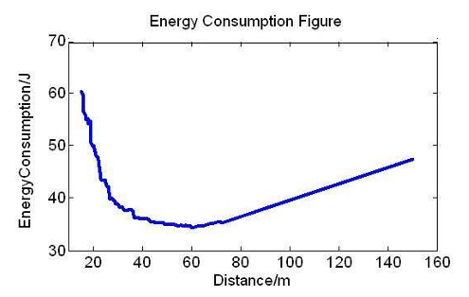Fig. 1. Energy consumption with different distances [5]

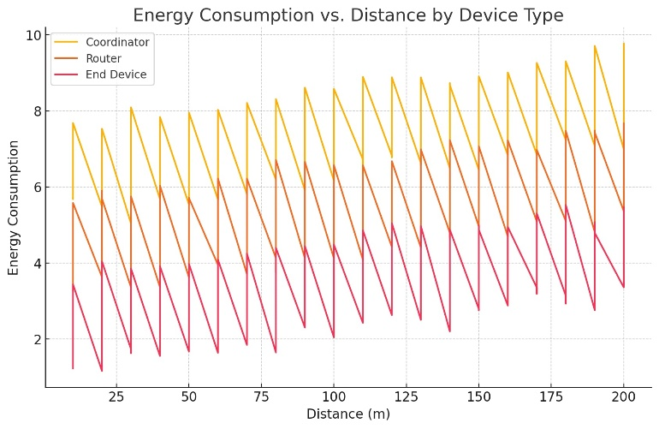 Fig. 2. Energy consumption with different distances by ChatGPT

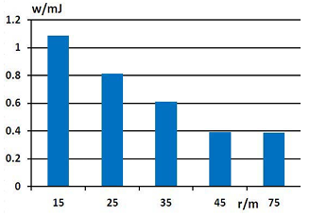
Fig. 3. Mean energy and communicating radius [5]

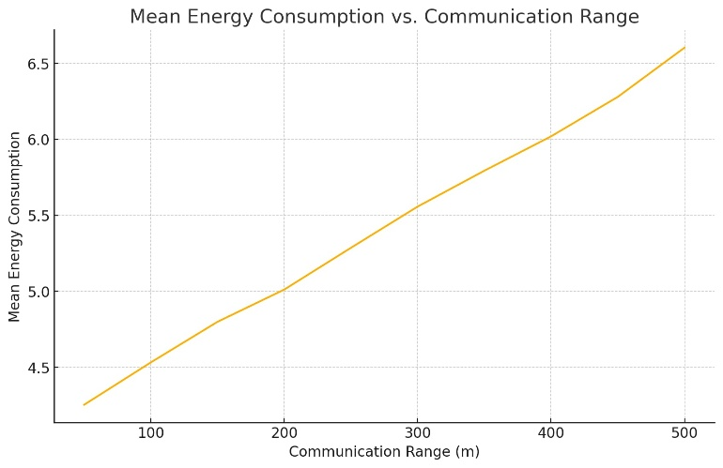Fig. 4. Mean energy and communicating radius by ChatGPT

EDIANA Platform
ChatGPT was prompted to provide a good strategy for energy efficiency in a Zigbee setting to verify whether it can still provide useful information regarding its given strategies at the start. In their response, ChatGPT provided a strategy for energy efficiency in a ZigBee setting that closely mirrors the approach in the study [2]. It recommended starting with selecting a simulation platform, setting up the network topology, and defining simulation parameters, like the study’s setup of a ZigBee mesh topology, and defining parameters like packet error delivery, delay, and energy consumption. ChatGPT also suggested implementing an Adaptive Transmission Power Control Algorithm based on RSSI, distance, and energy thresholds, which aligns with the study’s event-driven, query-based, and command-based adjustment strategies. The following steps, including evaluating energy consumption, analyzing network performance, and documenting findings, were also similar. Overall, ChatGPT's approach was aligned with the study's findings.

ADAPT Algorithm
ChatGPT’s response outlined a set of strategies for optimizing energy efficiency and reliability in IEEE 802.15.4/ZigBee networks that resonate well with the ADAPT algorithm's objectives. First, ChatGPT suggested adaptive duty cycling based on data reliability requirements, which complements ADAPT’s approach of dynamically adjusting MAC parameters; this would allow nodes to adjust duty cycles temporarily for high-priority transmissions, conserving energy for non-critical data. Additionally, ChatGPT proposed using link quality metrics, like RSSI or Packet Delivery Ratio (PDR), alongside energy metrics in routing decisions, a strategy that would extend ADAPT’s local parameter adjustments by favoring more reliable routes to reduce retransmissions. ChatGPT’s suggestion for dynamic transmission power adjustment based on reliability needs aligns with ADAPT’s adaptability, further balancing power use by tailoring transmission strength to the importance of each message. Reliability-aware sleep scheduling, particularly for cluster heads in a multi-hop setup, was another recommendation that fits well with ADAPT’s efficient resource management goals, providing backup nodes to support critical functions without overtaxing primary nodes. Lastly, ChatGPT’s idea for predictive reliability modeling to dynamically compress and aggregate data aligns with ADAPT’s aim to minimize energy consumption for routine data, while maximizing reliability for critical transmissions. Together, these strategies echo and expand upon ADAPT’s framework, reinforcing the algorithm's ability to balance energy and reliability in response to real-time network demands.

Conclusion
After multiple prompts created by ChatGPT and verifying the information it provided against the studies considered in this paper, it can be concluded that ChatGPT is reliable in some situations, such as serving as a starting point for identifying challenges in a topic and offering solutions based on its suggestions. However, ChatGPT is less reliable when it lacks specific information, particularly in simulating or creating models, as it does not account for real-time errors, which simulations typically fail to address. Overall, the strategies discussed in this paper are useful, as each study provides evidence for its claims through simulation and experimentation. Future research should focus on improving simulation models to better account for real-time errors and environmental variables, as these factors significantly impact the accuracy and applicability of findings, especially when using AI assistants.

References
- A. Ahmad and Z. Hanzalek, “An Energy Efficient Schedule for IEEE 802.15.4/ZigBee Cluster Tree WSN with Multiple Collision Domains and Period Crossing Constraint,” IEEE Transactions on Industrial Informatics, vol. 14, no. 1, pp. 12–23, Jul. 2017, doi: 10.1109/tii.2017.2725907.
- C. Gezer, M. Niccolini, and C. Buratti, “An IEEE 802.15.4/ZigBeE based wireless sensor network for energy efficient buildings,” IEEE Xplore, pp. 486–491, Oct. 2010, doi: 10.1109/wimob.2010.5645021.
- H. Ayadi, A. Zouinkhi, B. Boussaid, M. N. Abdelkrim, and T. Val, “Energy efficiency in WSN: IEEE 802.15.4,” 17th International Conference on Sciences and Techniques of Automatic Control and Computer Engineering (STA), Dec. 2016, doi: 10.1109/sta.2016.7952060.
- M. Di Francesco, G. Anastasi, M. Conti, S. K. Das, and V. Neri, “Reliability and Energy-Efficiency in IEEE 802.15.4/ZigBee Sensor Networks: An Adaptive and Cross-Layer Approach,” IEEE Journal on Selected Areas in Communications, vol. 29, no. 8, pp. 1508–1524, Aug. 2011, doi: 10.1109/jsac.2011.110902.
- O. Fan, X. Dongdong, Z. Xingnan, and C. Chunlin, “Modeling and analysis of energy consumption for ZigBee-based wireless sensor networks,” Chinese Control Conference, pp. 6638–6643, Jul. 2012, [Online]. Available: http://ieeexplore.ieee.org/iel5/6373891/6389889/06391105.pdf

